Shared Farm

Section 1 – Introduction:

1.0 Introduction:
This document defines the technical and functional specifications of the Shared Farm System, an intelligent web-based platform designed to connect farmers, investors, shareholders, delivery partners, and consumers within a unified digital environment. The document describes the software’s purpose, scope, functions, and expected behavior.
The Shared Farm System acts as a transparent agricultural marketplace and management solution. It allows customers to purchase fresh produce directly from verified farms, shareholders to manage their produce entitlements, and investors to participate in sustainable farm projects. The system also supports administrators and community members by integrating logistics, education, and sustainability tracking into a single platform.
The platform emphasizes transparency, automation, and collaboration. By embedding artificial-intelligence-based forecasting and recommendation models, it improves production planning, minimizes waste, and enhances decision-making for all participants. The system operates through a modern, scalable architecture accessible from both desktop and mobile devices.

1.1 Goals and Objectives:
The main goal of the Shared Farm System is to promote community-driven agriculture and enable digital participation in farming, trading, and investment.
The project has the following key objectives:
- To design an integrated online platform that connects customers, farmers, shareholders, investors, and administrators.
- To ensure transparent and traceable farm-to-consumer transactions supported by verified data.
- To introduce AI-powered tools for demand forecasting, inventory automation, and personalized product recommendations.
- To provide shareholders and investors with real-time dashboards showing productivity, sustainability, and financial indicators.
- To encourage community education through workshops, events, and resource-sharing features.
- To establish secure digital payments, refunds, and entitlement management.
- To support long-term scalability by integrating logistics APIs, payment gateways, and environmental data sources.

1.2 Statement of Scope:
The scope of the Shared Farm System is to build a centralized digital ecosystem that streamlines agricultural production, distribution, and investment. The system facilitates collaboration between multiple roles—customers, shareholders, investors, administrators, delivery partners, and community members—each with specific access privileges.
Customers can browse farm produce, place orders, and receive deliveries directly from verified sources. Shareholders can upload surplus stock, claim entitlements, and monitor farm performance. Investors can fund agricultural projects, view returns, and track sustainability outcomes. Administrators manage users, verify data, and moderate community activities. Delivery partners coordinate logistics and confirm deliveries, while community members engage in workshops and educational content.
The software ensures data accuracy through real-time validation and secure record-keeping. It integrates machine-learning models for forecasting, automated inventory control, and user-centric recommendations to improve efficiency and reduce waste.

The following table ranks the major processing functions that define the core scope of the system.
Function | Description | Priority
Creating Accounts and Logging In | Allows all users to register, log in, and access personalized dashboards. Role-based permissions determine available features. | Essential
Product Browsing and Filtering | Lets customers view farm produce, apply filters by type, origin, and price, and access sustainability data. | Essential
Order Placement and Checkout | Handles shopping-cart functions, payment verification, and order confirmation with digital receipts. | Essential
Payment Processing and Refunds | Verifies payments through gateways, authenticates transactions, and manages refund requests. | Essential
Delivery Scheduling and Tracking | Coordinates delivery partners, schedules time slots, and updates delivery status for customers. | Essential
Shareholder Entitlement Management | Enables shareholders to claim produce shares and monitor delivery or transfer of entitlements. | Essential
Surplus Produce Exchange | Allows shareholders to list excess produce for exchange or donation with administrative approval. | Essential
Investment Management | Provides investors access to farm projects, allows secure funding, and tracks financial and environmental returns. | Essential
Sustainability Dashboard | Displays analytics on water usage, carbon savings, and waste reduction metrics for farms. | Desirable
AI Demand Forecasting | Predicts produce demand to plan harvest cycles and minimize waste. | Essential
AI Stock Automation | Monitors real-time stock levels, issues low-stock alerts, and triggers auto-restock processes. | Essential
AI Recommendations and Recipes | Suggests personalized product bundles, recipes, and storage tips based on purchase history. | Essential
AI Resource Optimization | Analyses farm resource usage to recommend efficient allocation of equipment and inputs. | Desirable
Community Workshops and Events | Allows users to register for events, share experiences, and access learning materials. | Essential
Administrative Control | Enables administrators to manage users, approve transactions, and generate reports. | Essential
Customer Support and Chat | Offers chat assistance and automated inquiry responses. | Desirable
Data Validation and Verification | Confirms authenticity of user-submitted data and prevents duplication or false entries. | Essential
Reward and Loyalty System | Awards points for eco-friendly actions redeemable for discounts or event participation. | Future
Third-Party Farm Auditing | Integrates certified auditors for farm inspection and compliance verification. | Future
Fraud Detection and Security | Monitors irregular transaction patterns and flags suspicious activity. | Future
The system’s functionality ensures that every role can interact within the same environment while maintaining data integrity, user privacy, and operational transparency.

1.3 Software Context:
The Shared Farm System operates through a layered architecture that separates presentation, business logic, and data management. The front-end interface is developed using responsive web technology compatible with all major browsers and mobile devices. The application layer handles transactions, user authentication, order management, AI computations, and reporting.
All system data—including user information, produce listings, orders, and investment details—is securely stored in cloud databases. Artificial-intelligence modules run parallel to these processes, performing forecasting and recommendation tasks using historical data and real-time updates.
External integration plays a major role in system context. The platform connects with logistics APIs for delivery scheduling, payment gateways for secure transactions, and environmental databases for sustainability metrics. Its design emphasizes scalability, enabling easy addition of new farms, regions, and investors as the network expands.

1.4 Major Constraints:
Although the Shared Farm System is designed to deliver efficiency and transparency, several constraints must be considered:
- Data Accuracy: The reliability of AI modules depends on the accuracy of data uploaded by farms and users. Incomplete or outdated records may lead to forecasting errors.
- Internet Connectivity: Many farms are located in rural areas with limited network coverage, which may affect system performance.
- User Adoption: Farmers and shareholders unfamiliar with digital platforms may require orientation or support to effectively use the system.
- Integration Challenges: Incorporating external APIs such as weather data, logistics networks, and payment services can introduce compatibility and maintenance issues.
- Regulatory Compliance: Agricultural investment, data privacy, and food-safety regulations differ across jurisdictions and must be carefully followed.
- Security Risks: Because the system manages financial transactions, strict encryption and access-control mechanisms are required.
- Scalability: As participation increases, server resources and data-handling capacity must scale efficiently.
- AI Model Limitations: Predictive accuracy may fluctuate based on historical patterns and environmental changes.
The project will be considered successful if it delivers a functional, secure, and scalable platform that promotes transparency, sustainability, and stakeholder collaboration across the agricultural ecosystem.

Section 2 – Data Design:

2.0 Data Design:
This section defines all internal, global, and temporary data structures that form the foundation of the Shared Farm System. Each structure ensures reliable storage, retrieval, and processing of information within the platform.
The data design aims to maintain transparency, scalability, and efficiency across every user interaction — from farm-level operations to AI-driven analytics and community events.

2.1 Internal Software Data Structure:
The internal software structure is composed of interconnected components that collectively define the platform’s core logic and business operations. These structures form the operational backbone of Shared Farm.
- User Profile – Represents individuals interacting with the system. Each profile contains identifiers, contact data, credentials, preferences, and linked entities such as orders or investments. Users are categorized as Customer, Shareholder, Investor, Administrator, Community Member, or Delivery Partner.
- Produce Listing – Holds all product-related information such as produce ID, crop type, harvest date, price, quantity, origin farm, and sustainability metrics. It is directly linked to farmer and shareholder accounts.
- Order Record – Captures purchase details including order ID, customer ID, ordered items, delivery partner, payment method, and delivery status. Orders interact dynamically with inventory and logistics modules.
- Investment Portfolio – Manages investor contributions to ongoing farm projects. Each record includes investment ID, project name, funding amount, expected returns, and sustainability impact score.
- Entitlement Registry – Tracks shareholder allocations and produce claims. It includes entitlement ID, shareholder ID, product type, distribution date, and delivery status.
- AI Modules Data – Internal AI containers store processed data for demand forecasting, stock optimization, recommendations, and resource analytics.
- Community Engagement Record – Maintains logs of member participation in workshops, blog posts, and community events.
- Support Tickets and Reports – Contain complaint IDs, sender information, timestamps, issue type, status, and administrator response.
- Audit Logs – Track every major user and admin action for transparency and traceability.
- Loyalty Ledger – Tracks earned reward points for eco-friendly or community actions, enabling redemption in future purchases.

2.2 Global Data Structure:
The global data architecture provides centralized access for the entire system, integrating all operational modules under a unified database network.
Components:
- Cloud SQL Database: Core transactional data (users, orders, payments, inventory).
- AI Analytics Warehouse: Predictive models, aggregated forecasts, and trend data.
- Document Storage: Holds product images, certificates, and event resources.
- API Integration Layer: Handles external data from payment gateways, logistics partners, and agricultural datasets.
- Backup and Recovery Store: Nightly replication to ensure zero data loss.
Global structures use unique keys for all entities and enforce referential integrity across tables such as User, Product, Order, Investment, and Delivery.

2.3 Temporary Data Structure:
Temporary data elements are transient in nature and exist only for quick computation, caching, or buffering during active sessions.
Temporary Structure | Purpose
Session Cache | Stores active user session tokens, preferences, and temporary login states.
Search Cache | Retains recent search queries for faster re-access.
Cart Buffer | Maintains selected items before checkout; auto-expires after inactivity.
Notification Queue | Queues payment confirmations, stock alerts, and order updates.
Message Buffer | Temporarily holds messages exchanged during real-time chats.
AI Inference Cache | Stores intermediate results from forecasting models.
Delivery Dispatch Queue | Temporarily manages assignment of deliveries awaiting driver acceptance.
Event Feedback Queue | Collects workshop feedback before aggregation.
These structures are periodically flushed to maintain optimal performance and low memory consumption.

2.4 Database Description
The Shared Farm Database Model combines relational data storage for transactions and document storage for multimedia and AI outputs. It ensures ACID compliance, referential integrity, and secure multi-user access.

2.4.1 Core Database (Tables and Descriptions)

Table Name: User
Attribute | Data Type | Constraint
userID | string | Primary Key
name | string
email | string | Unique
passwordHash | string
phoneNumber | string
role | enum(Customer, Shareholder, Investor, Admin, DeliveryPartner, CommunityMember)
registrationDate | date
accountStatus | string | Default: Active
address | string
rewardPoints | int | Default: 0
lastLogin | date
Description:
Stores all registered users and their access roles; forms the parent reference for all dependent tables.

Table Name: Product
Attribute | Data Type | Constraint
productID | string | Primary Key
farmerID | string | Foreign Key(User.userID)
name | string
category | string
description | string
harvestDate | date
price | double
stock | int
certification | string
sustainabilityScore | double
imageURL | string
Description:
Represents produce listings available in the marketplace, each linked to its originating farmer.

Table Name: Order
Attribute | Data Type | Constraint
orderID | string | Primary Key
customerID | string | Foreign Key(User.userID)
productID | string | Foreign Key(Product.productID)
quantity | int
totalAmount | double
paymentID | string | Foreign Key(Payment.paymentID)
deliveryPartnerID | string | Foreign Key(User.userID)
orderDate | date
deliveryStatus | string | Default: Pending
trackingCode | string
Description:
Records every transaction from order placement to delivery completion.

Table Name: Investment
Attribute | Data Type | Constraint
investmentID | string | Primary Key
investorID | string | Foreign Key(User.userID)
projectName | string
fundingGoal | double
contribution | double
expectedReturn | double
status | string
startDate | date
maturityDate | date
Description:
Tracks investor contributions, expected ROI, and funding progress.

Table Name: Entitlement
Attribute | Data Type | Constraint
entitlementID | string | Primary Key
shareholderID | string | Foreign Key(User.userID)
productID | string | Foreign Key(Product.productID)
quantity | int
issueDate | date
deliveryStatus | string
Description:
Logs shareholder produce allocations and monitors their delivery or exchange status.

Table Name: Payment
Attribute | Data Type | Constraint
paymentID | string | Primary Key
orderID | string | Foreign Key(Order.orderID)
payerID | string | Foreign Key(User.userID)
amount | double
method | string
paymentDate | date
status | string
refundStatus | string | Default: None
referenceNumber | string
Description:
Captures transaction details, ensuring secure recording of financial activities.

Table Name: Delivery
Attribute | Data Type | Constraint
deliveryID | string | Primary Key
orderID | string | Foreign Key(Order.orderID)
deliveryPartnerID | string | Foreign Key(User.userID)
pickupTime | date
deliveryTime | date
status | string | Default: Scheduled
route | string
feedback | string
Description:
Stores logistics details for each order’s delivery process.

Table Name: SustainabilityMetric
Attribute | Data Type | Constraint
metricID | string | Primary Key
farmID | string | Foreign Key(User.userID)
waterUsage | double
fertilizerUsage | double
energyConsumption | double
carbonSaved | double
reportDate | date
Description:
Holds sustainability KPIs and supports the AI modules in evaluating performance.

Table Name: CommunityEvent
Attribute | Data Type | Constraint
eventID | string | Primary Key
eventName | string
eventDate | date
location | string
organizerID | string | Foreign Key(User.userID)
description | string
maxParticipants | int
registeredUsers | int
Description:
Represents training sessions, workshops, and community outreach activities.

Table Name: SupportTicket
Attribute | Data Type | Constraint
ticketID | string | Primary Key
userID | string | Foreign Key(User.userID)
issueType | string
description | string
status | string
assignedAgent | string
createdAt | date
resolvedAt | date
Description:
Records support requests and their resolution history.

Table Name: AuditLog
Attribute | Data Type | Constraint
logID | string | Primary Key
userID | string | Foreign Key(User.userID)
actionType | string
actionDetail | string
timestamp | date
ipAddress | string
Description:
Captures all significant system actions for accountability and traceability.

2.4.2 AI and Analytics Database

Table Name: DemandForecast
Attribute | Data Type | Constraint
forecastID | string | Primary Key
productID | string | Foreign Key(Product.productID)
forecastDate | date
predictedDemand | double
confidence | double
modelVersion | string
generatedBy | string
Description:
AI-based forecast records used to predict upcoming demand.

Table Name: RecommendationRecord
Attribute | Data Type | Constraint
recordID | string | Primary Key
userID | string | Foreign Key(User.userID)
recommendedItems | string
generatedAt | date
rating | double
feedback | string
Description:
Logs AI-generated recommendations, recipes, and storage tips for users.

Table Name: ResourceOptimization
Attribute | Data Type | Constraint
optimizationID | string | Primary Key
farmID | string | Foreign Key(User.userID)
parameter | string
suggestedAction | string
expectedGain | double
generatedAt | date
Description:
Contains AI-suggested improvements for resource use (water, fertilizer, energy).

Table Name: AlertQueue
Attribute | Data Type | Constraint
alertID | string | Primary Key
productID | string | Foreign Key(Product.productID)
alertType | string
message | string
createdAt | date
status | string | Default: Pending
Description:
Stores automated alerts triggered by stock, delivery, or payment events.

Table Name: LoyaltyLedger
Attribute | Data Type | Constraint
entryID | string | Primary Key
userID | string | Foreign Key(User.userID)
activityType | string
pointsEarned | int
date | date
redeemed | bool
Description:
Manages reward points and eco-action credits for users.

Section 3 – Architectural and Component-Level Design:

3.0 Architectural and Component-Level Design:
Suitable Architecture Style: Layered Architecture Style
Reasoning:
Layered architecture is the optimal choice for the Shared Farm System due to several critical factors. This architectural pattern allows clear separation of concerns across different functional layers, which benefits both design and implementation phases. In an agricultural marketplace that integrates multiple stakeholders, AI-driven analytics, payment processing, and real-time logistics, a layered approach provides the modularity needed to manage complexity effectively.
The layered design offers easy maintenance and modification capabilities. As agricultural technology, payment systems, and AI models evolve rapidly, the ability to update individual layers without disrupting the entire system is invaluable. For instance, upgrading the AI forecasting module or integrating a new payment gateway can be accomplished within specific layers without affecting user interfaces or database structures.
Additionally, layered architecture provides excellent scalability—a crucial requirement as the platform expands to accommodate more farms, regions, investors, and community members. Each layer can be scaled independently based on demand, whether it's adding more database replicas for data storage or enhancing processing power for AI computations.
This architecture also enhances security by establishing clear boundaries between user-facing components and sensitive data storage, allowing for targeted security measures at each layer. The separation of presentation, business logic, and data management aligns perfectly with the system's need for role-based access control and secure financial transactions.
Our layered architecture consists of 4 layers:

Presentation Layer (Layer 3)
Description:
The Presentation Layer is the topmost layer and serves as the primary interface between users and the Shared Farm System. This layer is responsible for capturing all user inputs and displaying system outputs in an intuitive, responsive format accessible across desktop browsers and mobile devices.
Responsibilities:
- User Interface Rendering: Displays dashboards customized for each user role (Customer, Shareholder, Investor, Administrator, Delivery Partner, Community Member)
- Input Collection: Captures user actions including registration, login credentials, product searches, order placements, investment selections, and event registrations
- Data Visualization: Presents sustainability metrics, financial analytics, demand forecasts, and delivery tracking through charts, graphs, and interactive maps
- Navigation Control: Manages page routing, menu systems, and user flow throughout the application
- Responsive Design: Ensures optimal display and functionality across various screen sizes and devices
- Session Management: Maintains active user sessions and handles timeouts
Key Components:
- Customer Marketplace Interface
- Shareholder Entitlement Portal
- Investor Dashboard
- Administrator Control Panel
- Delivery Partner Logistics Interface
- Community Engagement Hub
- Authentication Forms
- Notification Display System
Data Flow:
All user inputs collected in this layer are passed down to the Application Layer for validation and processing. Conversely, processed information, analytics, and system responses are received from the Application Layer and displayed to users in readable, visual formats.

Application Layer (Layer 2)
Description:
The Application Layer contains all core business logic and functional processing capabilities of the Shared Farm System. This layer acts as the intelligence hub, processing requests from the Presentation Layer, executing business rules, coordinating workflows, and managing communication between the user interface and data storage.
Responsibilities:
- User Authentication & Authorization: Validates login credentials, manages role-based permissions, and controls access to features
- Order Processing: Handles shopping cart operations, calculates totals, applies discounts, and manages checkout workflows
- Payment Validation: Interfaces with payment gateways, verifies transactions, and processes refund requests
- Entitlement Management: Calculates shareholder allocations, validates claims, and manages produce distribution
- Investment Processing: Evaluates project eligibility, processes funding contributions, and tracks returns
- AI Module Coordination: Triggers demand forecasting, stock automation, recommendation generation, and resource optimization
- Delivery Scheduling: Coordinates logistics, assigns delivery partners, and updates tracking status
- Data Validation: Ensures all user-submitted information meets quality and format requirements
- Community Event Management: Handles event registrations, participant tracking, and feedback collection
- Notification Generation: Creates alerts for stock levels, payment confirmations, delivery updates, and system events
- Report Generation: Compiles analytics, sustainability reports, and administrative summaries
- Business Rule Enforcement: Implements pricing logic, inventory rules, and transaction policies
Key Components:
- User Account Management Module
- Product Catalog & Search Engine
- Order Management System
- Payment Processing Interface
- Shareholder Entitlement Engine
- Investment Management Module
- AI Integration Controller
- Logistics Coordination System
- Community Event Coordinator
- Administrative Control Module
- Support Ticket Handler
- Reward & Loyalty Calculator
Data Flow:
This layer receives validated user inputs from the Presentation Layer, applies business logic and computations, then either retrieves information from or stores information to the Data & Analytics Layer. Processed results and system responses are sent back up to the Presentation Layer for user display.

Data & Analytics Layer (Layer 1)
Description:
The Data & Analytics Layer serves as the intelligent storage and processing backbone of the Shared Farm System. This layer is divided into two parallel subsystems: the Core Database System for transactional and operational data, and the AI Analytics Engine for predictive modeling and intelligent recommendations.
Responsibilities:
Core Database System:
- Persistent Data Storage: Stores all user profiles, product listings, orders, investments, entitlements, payments, deliveries, and audit logs
- Data Integrity Management: Enforces referential integrity, constraints, and ACID compliance across all transactions
- Query Processing: Executes complex database queries for retrieval, updates, insertions, and deletions
- Backup & Recovery: Performs nightly replications and maintains recovery points
- Concurrency Control: Manages simultaneous access from multiple users and processes
AI Analytics Engine:
- Demand Forecasting: Analyzes historical purchase patterns and seasonal trends to predict future demand
- Stock Optimization: Monitors inventory levels in real-time and triggers automated restock alerts
- Personalized Recommendations: Generates product suggestions, recipes, and storage tips based on user behavior
- Resource Optimization: Evaluates farm sustainability metrics and recommends efficiency improvements
- Trend Analysis: Identifies patterns in user behavior, sales, and farm performance
- Model Training & Refinement: Continuously improves AI accuracy using new data
Key Components:
Database Components:
- User Table (profiles, credentials, roles)
- Product Table (produce listings, pricing, stock)
- Order Table (transactions, delivery status)
- Investment Table (projects, contributions, returns)
- Entitlement Table (shareholder allocations)
- Payment Table (financial transactions)
- Delivery Table (logistics details)
- Sustainability Metrics Table (environmental KPIs)
- Community Event Table (workshops, registrations)
- Support Ticket Table (user assistance)
- Audit Log Table (system actions)
AI Components:
- Demand Forecast Module
- Stock Automation Engine
- Recommendation Generator
- Resource Optimization Analyzer
- Alert Queue Manager
- Loyalty Points Calculator
Data Flow:
The Application Layer sends queries, data insertion requests, and AI computation triggers to this layer. The Core Database System responds with requested records or confirmation of data operations. The AI Analytics Engine processes data patterns and returns forecasts, recommendations, and optimization suggestions back to the Application Layer.

Integration & Infrastructure Layer (Layer 0)
Description:
The Integration & Infrastructure Layer is the foundational layer that manages external connections, system infrastructure, and technical services that support all upper layers. This layer ensures the Shared Farm System can communicate with third-party services and maintain operational stability.
Responsibilities:
- External API Integration: Manages connections to payment gateways, logistics partners, weather data sources, and environmental databases
- Cloud Infrastructure Management: Oversees cloud server resources, load balancing, and scaling operations
- Security Services: Implements encryption, SSL certificates, firewall rules, and intrusion detection
- Network Communication: Handles HTTP/HTTPS protocols, WebSocket connections for real-time updates
- Cache Management: Operates temporary data structures for sessions, search queries, and notifications
- Monitoring & Logging: Tracks system performance, uptime, error rates, and resource utilization
- Email & SMS Services: Sends notification emails and text messages for alerts and confirmations
- File Storage Services: Manages document storage for product images, certificates, and event materials
Key Components:
- Payment Gateway Connectors (Stripe, PayPal, local payment processors)
- Logistics API Integration (delivery routing, tracking services)
- Environmental Data APIs (weather, soil conditions, sustainability databases)
- Cloud Service Provider Interface (AWS, Azure, Google Cloud)
- Email Service Provider (SendGrid, AWS SES)
- SMS Gateway Service
- Content Delivery Network (CDN) for images and media
- Security & Firewall Systems
- Backup Storage Systems
- Session Cache Storage (Redis, Memcached)
- Notification Queue Manager
Data Flow:
This layer receives external service requests from the Application Layer (such as processing a payment or scheduling a delivery) and communicates with third-party APIs to fulfill these requests. Responses from external services are validated and passed back to the Application Layer. Infrastructure services continuously support all layers by providing networking, caching, security, and monitoring capabilities.
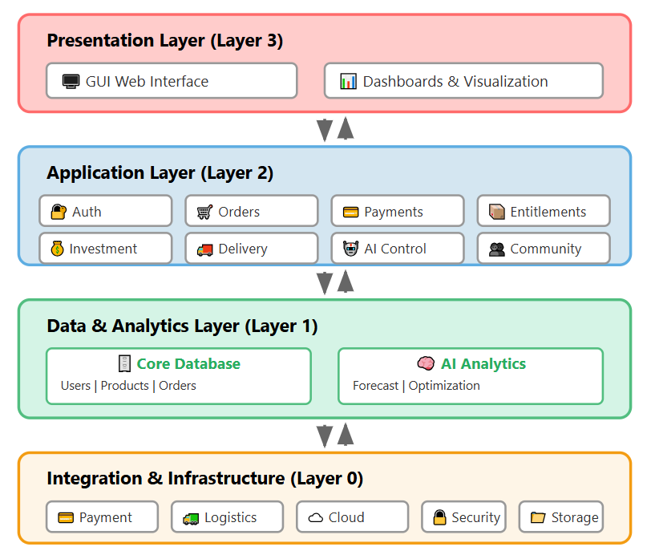

3.1 System Structure:

3.1.1 Architecture Diagram:
The following class diagram illustrates the complete object-oriented structure of the Shared Farm System, showing all major classes, their attributes, methods, and relationships. The diagram is organized to demonstrate the interactions between users, products, transactions, AI modules, and administrative components.
Diagram Overview:
- User Management Classes: Handle authentication, roles, and profiles
- Product & Inventory Classes: Manage farm produce listings and stock
- Transaction Classes: Process orders, payments, and deliveries
- Shareholder & Investment Classes: Manage entitlements and funding
- AI & Analytics Classes: Provide intelligent forecasting and recommendations
- Community & Support Classes: Enable engagement and assistance
- Administrative Classes: Control system operations and reporting

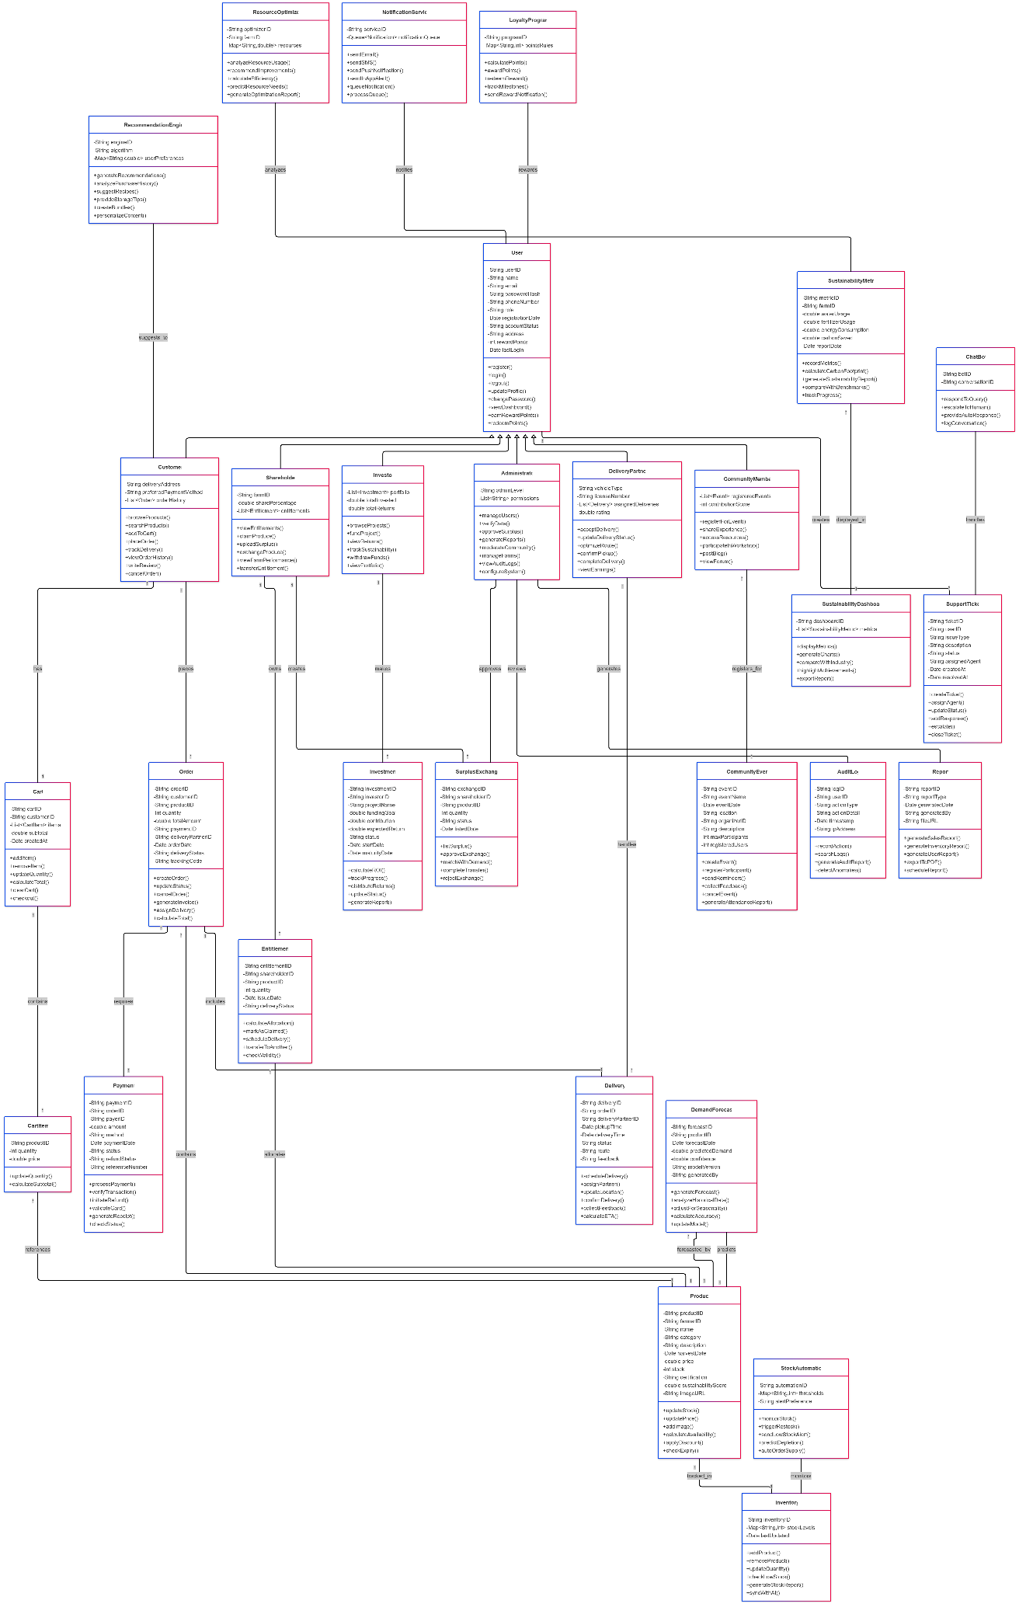
For clarity we made parts of the class diagram to be more visible
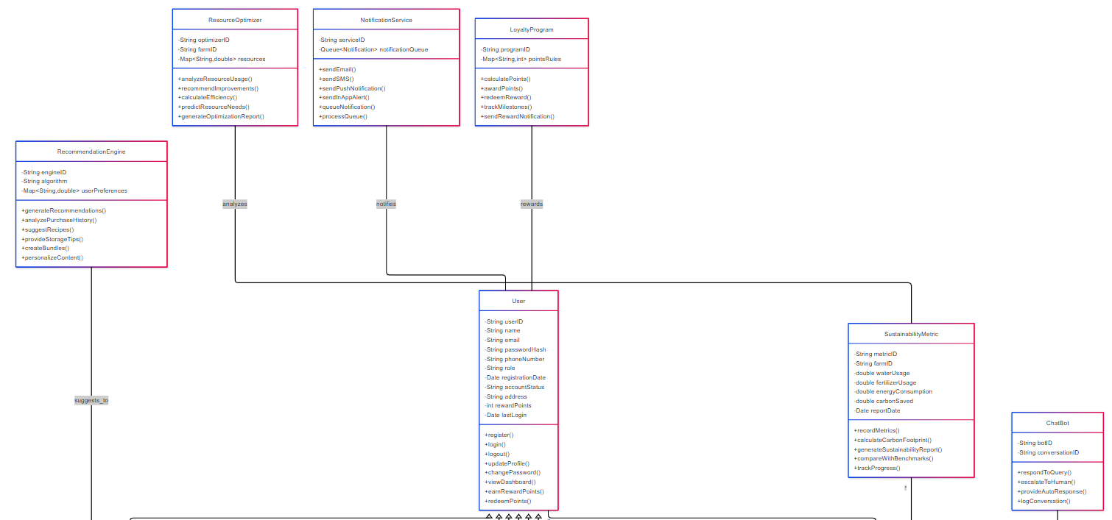

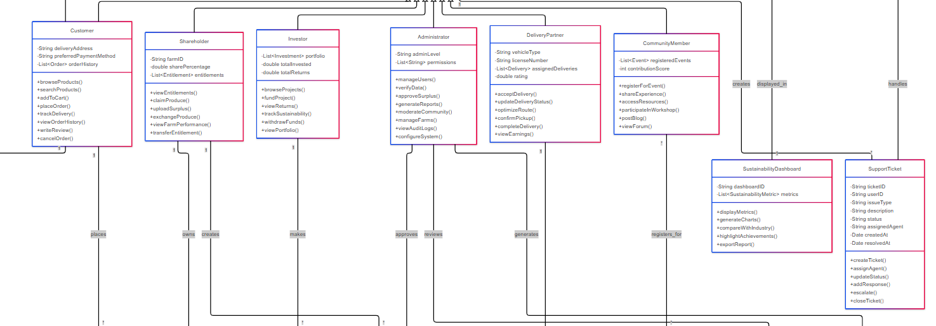
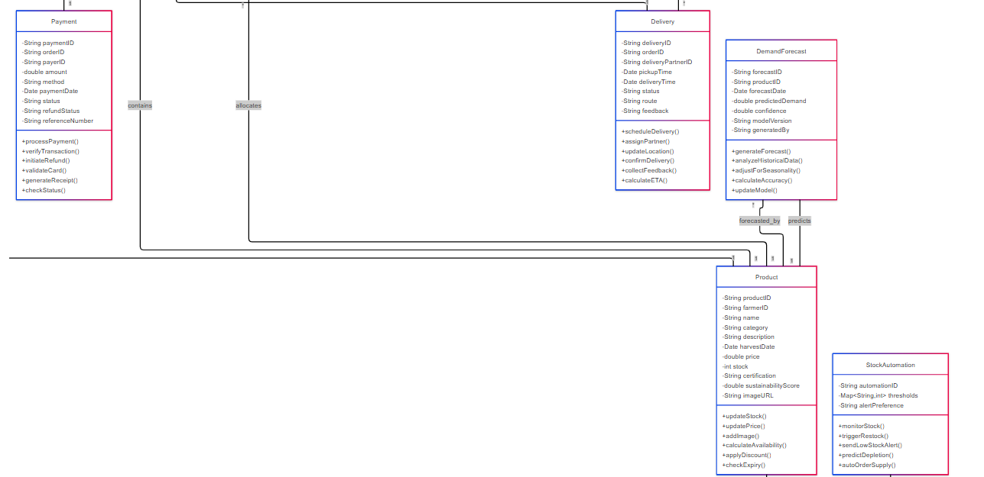
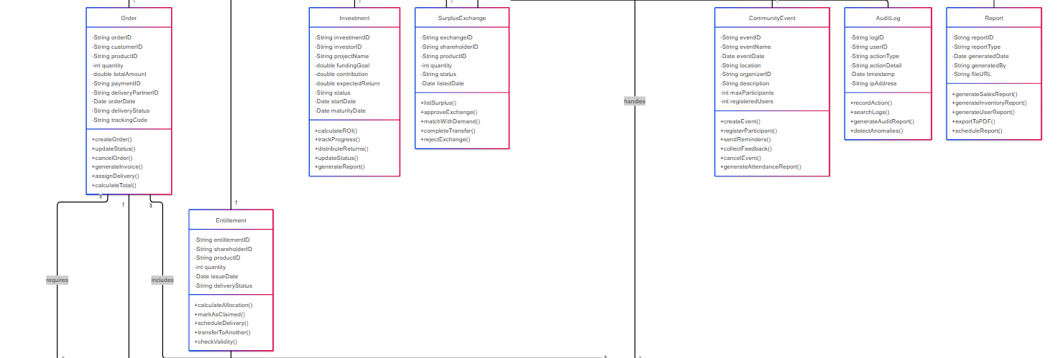

3.2 Description for Components

3.2 Description for Component User

3.2.1 Processing narrative (PSPEC) for component User
The User component manages authentication, profile management, and user interactions. It handles registration, login, password management, reward points, transaction history, and support ticket submission for all platform participants (Customers, Shareholders, Investors, Administrators, Delivery Partners, and Community Members).

3.2.2 Component User interface description
The User interface appears when users open the application, requiring authentication before accessing features. It displays login/registration forms, verifies credentials through the database, and routes authenticated users to role-specific dashboards.

3.2.3 Component User processing detail
- Start
- User opens application
- User selects login or registration
- System validates credentials
- User accesses dashboard based on role
- User can view history, earn points, or submit tickets
- End

3.2.3.1 Design Class hierarchy for component User
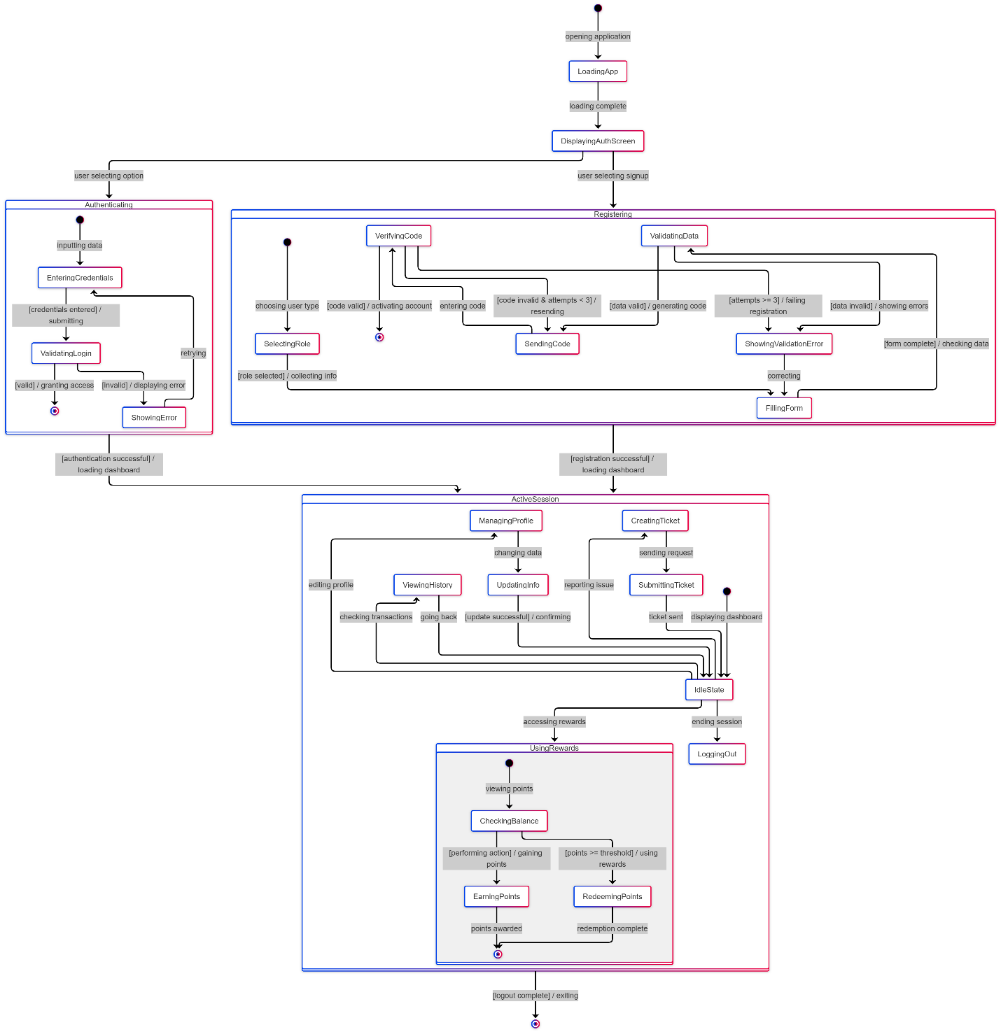

3.2.3.2 Restrictions/limitations for component User
Users cannot access features without authentication. Email and phone verification required. Maximum 3 failed login attempts before temporary lock. Password reset limited to 3 verification attempts.

3.2.3.3 Performance issues for component User
Simultaneous login requests during peak hours may cause delays. Concurrent database queries for authentication may slow response time.

3.2.3.4 Design constraints for component User
Passwords must be 8+ characters with mixed case, numbers, and symbols. Session timeout after 30 minutes of inactivity. All authentication data encrypted in transit and at rest.

3.2.3.5 Processing detail for each operation of component User
- register(name: String, email: String, password: String, role: String): Boolean
- login(credential: String, password: String): Boolean
- updateProfile(field: String, newValue: String): Boolean
- changePassword(oldPassword: String, newPassword: String): Boolean
- verifyCode(userCode: String): Boolean
- earnRewardPoints(activityType: String, points: Int): Void
- redeemPoints(pointsAmount: Int): Boolean
- submitTicket(issueType: String, description: String): Ticket

3.2.3.5.1 Processing narrative (PSPEC) for each operation
- register() - Creates new user account with role assignment and sends verification code
- login() - Authenticates existing user and creates session token
- updateProfile() - Modifies user information with validation
- changePassword() - Updates password after verifying current password
- verifyCode() - Validates verification code for account activation
- earnRewardPoints() - Awards points for activities and updates loyalty ledger
- redeemPoints() - Exchanges points for benefits if threshold met
- submitTicket() - Creates support ticket and assigns to agent

3.2.3.5.2 Algorithmic model (PDL) for each operation
1. register()
Start
Input: name, email, password, role
Validate email format
IF email invalid THEN Return error
Check email exists in database
IF email exists THEN Return "Already registered"
Validate password strength
IF password weak THEN Return error
Hash password
Generate userID and set accountStatus = "Pending"
Save to database
Generate 6-digit code
Send code via email
Return success
End
2. login()
Start
Input: credential, password
Query user by credential
IF user not found THEN Return "Invalid credentials"
Verify password against hash
IF incorrect THEN
Increment failed attempts
IF attempts >= 5 THEN Lock account
Return error
END IF
Generate session token
Update lastLogin timestamp
Return success with token
End
3. updateProfile()
Start
Input: field, newValue
Validate newValue format
IF invalid THEN Return error
IF field = "email" THEN
Check if email exists
IF exists THEN Return "Email in use"
Update email and set status = "Pending Verification"
ELSE
Update field directly
END IF
Save to database
Return success
End
4. changePassword()
Start
Input: oldPassword, newPassword
Verify oldPassword
IF incorrect THEN Return "Wrong password"
Validate newPassword strength
IF weak THEN Return error
Hash newPassword
Update database
Send confirmation email
Return success
5. verifyCode()
Start
Input: userCode
Retrieve stored code and expiration
IF expired THEN Return "Code expired"
Compare codes
IF match THEN
Set accountStatus = "Active"
Return true
ELSE
Return false
END IF
End
6. earnRewardPoints()
Start
Input: activityType, points
Retrieve current rewardPoints
Add points to total
Update database
Create LoyaltyLedger entry
IF total >= milestone THEN Send notification
Return
End
7. redeemPoints()
Start
Input: pointsAmount
Retrieve rewardPoints
IF points < pointsAmount THEN Return "Insufficient points"
Subtract points
Update database
Generate discount code
Return success with code
End
8. submitTicket()
Start
Input: issueType, description
Generate ticketID
Set status = "Open", createdAt = now
Assign to available agent
Save to database
Send notification to agent
Return ticket
End

3.2 Description for Component Order

3.2.1 Processing narrative (PSPEC) for component Order
The Order component manages purchase transactions from cart creation to delivery completion. It handles order placement, payment coordination, delivery assignment, status tracking, cancellations, and invoice generation.

3.2.2 Component Order interface description
Displays when customers proceed to checkout. Shows cart summary, delivery options, payment methods, and order tracking. Updates real-time delivery status and allows order modifications within cancellation window.

3.2.3 Component Order processing detail
- Start
- Customer adds products to cart
- Customer proceeds to checkout
- System validates availability and calculates total
- Customer completes payment
- System creates order and assigns delivery partner
- Order progresses through delivery stages
- Customer confirms receipt
- End

3.2.3.1 Design Class hierarchy for component Order

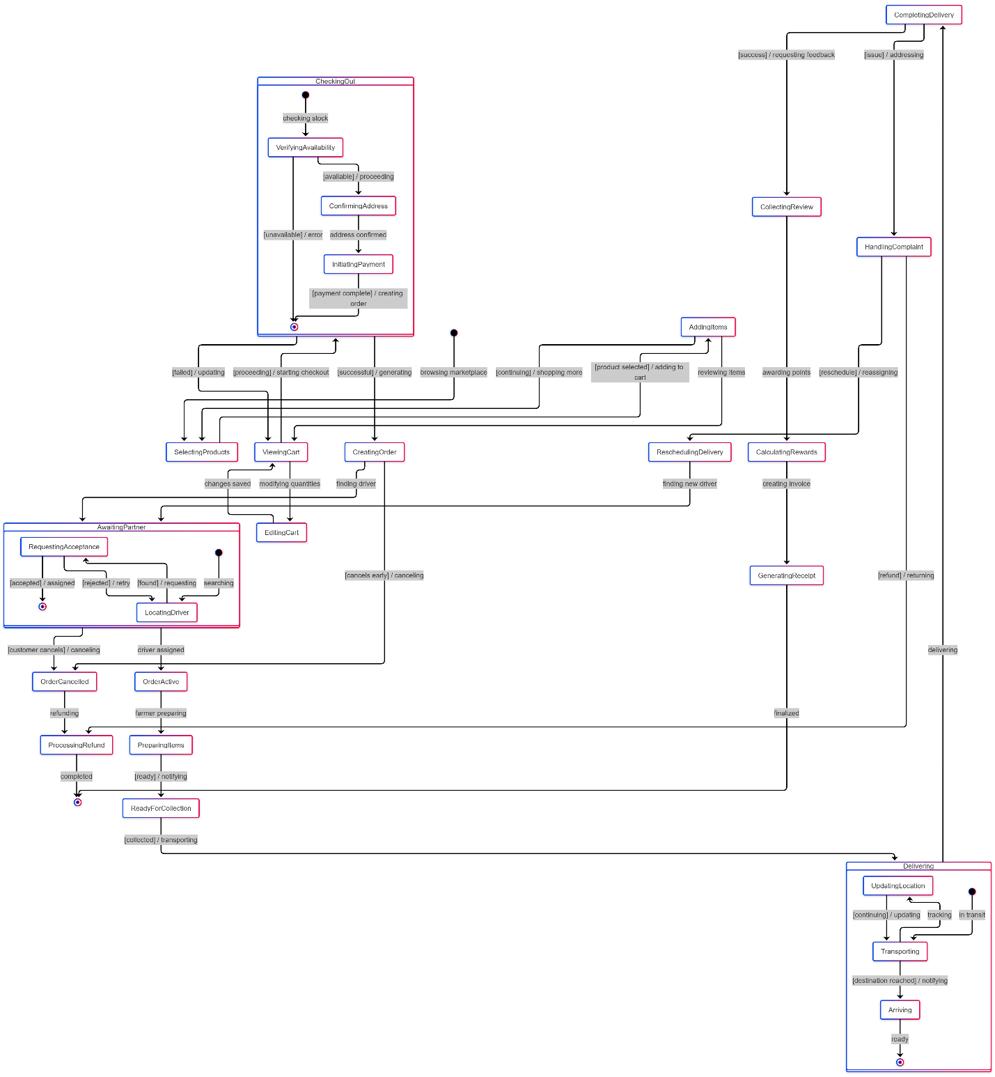3.2.3.2 Restrictions/limitations for component Order
Orders cannot be placed with out-of-stock items. Cancellation allowed only within 2 hours of placement. Delivery address cannot be changed after partner assignment. Minimum order value of $10 required.

3.2.3.3 Performance issues for component Order
Multiple simultaneous orders on same product may cause stock inconsistency. Peak hour order processing may delay delivery partner assignment. Large order volumes may slow invoice generation.

3.2.3.4 Design constraints for component Order
Each order limited to 50 items maximum. Delivery slots limited to available time windows. Order tracking updates every 5 minutes during transit. Payment timeout after 10 minutes of inactivity.

3.2.3.5 Processing detail for each operation of component Order
- createOrder(customerID: String, items: List, deliveryAddress: String): Order
- calculateTotal(items: List): Double
- updateStatus(orderID: String, newStatus: String): Void
- cancelOrder(orderID: String, reason: String): Boolean
- assignDeliveryPartner(orderID: String): DeliveryPartner
- generateInvoice(orderID: String): Invoice
- trackOrder(orderID: String): Location
- confirmDelivery(orderID: String, signature: String): Boolean

3.2.3.5.1 Processing narrative (PSPEC) for each operation
- createOrder() - Generates new order after payment confirmation and deducts stock
- calculateTotal() - Computes total price including taxes and delivery fees
- updateStatus() - Changes order delivery status and notifies customer
- cancelOrder() - Processes cancellation if within allowed window and initiates refund
- assignDeliveryPartner() - Finds available partner and sends delivery request
- generateInvoice() - Creates detailed receipt with itemized charges
- trackOrder() - Returns current location and estimated delivery time
- confirmDelivery() - Marks order complete upon customer confirmation

3.2.3.5.2 Algorithmic model (PDL) for each operation
1. createOrder()
Start
Input: customerID, items, deliveryAddress
Validate items availability
IF any item unavailable THEN Return error
Generate unique orderID
Set orderDate = now, status = "Pending"
Generate trackingCode
FOR each item IN items DO
Deduct quantity from stock
END FOR
Save order to database
Notify farmer
Return order
End
2. calculateTotal()
Start
Input: items
Initialize total = 0
FOR each item IN items DO
total = total + (item.price * item.quantity)
END FOR
Calculate tax = total * 0.08
Calculate deliveryFee based on distance
total = total + tax + deliveryFee
Return total
End
3. updateStatus()
Start
Input: orderID, newStatus
Retrieve order from database
Update deliveryStatus = newStatus
Update timestamp
Save to database
Send notification to customer
Log in AuditLog
Return
End
4. cancelOrder()
Start
Input: orderID, reason
Retrieve order
Calculate time since orderDate
IF time > 2 hours THEN Return "Cannot cancel"
IF status = "InTransit" THEN Return "Too late to cancel"
Set status = "Canceled"
FOR each item IN order DO
Restore stock quantity
END FOR
Initiate refund process
Update database
Return true
End
5. assignDeliveryPartner()
Start
Input: orderID
Retrieve order details
Query available delivery partners near deliveryAddress
IF no partners available THEN
Set order status = "Delayed"
Return null
END IF
Select partner with highest rating
Send delivery request to partner
Wait for acceptance
IF accepted THEN
Update order with deliveryPartnerID
Return partner
ELSE
Find next available partner
Repeat process
END IF
End
6. generateInvoice()
Start
Input: orderID
Retrieve order details
Retrieve customer information
Retrieve product details
Create invoice document with:
- Order ID and date
- Customer details
- Itemized product list
- Subtotal, tax, delivery fee
- Total amount
- Payment method
Generate PDF
Store in document storage
Return invoice
End
7. trackOrder()
Start
Input: orderID
Retrieve order with trackingCode
IF status = "Pending" THEN
Return "Order being prepared"
ELSE IF status = "InTransit" THEN
Query delivery partner location
Calculate ETA based on current location
Return location and ETA
ELSE IF status = "Delivered" THEN
Return "Order delivered"
END IF
End
8. confirmDelivery()
Start
Input: orderID, signature
Retrieve order
IF status != "AtDestination" THEN Return false
Update status = "Delivered"
Store signature
Set deliveryTime = now
Update database
Trigger reward points calculation
Generate final invoice
Return true
End

